Lab: CSS Selectors and Rules
- Plan Page
You are given the HTML for the Web page shown below. Write the missing CSS:
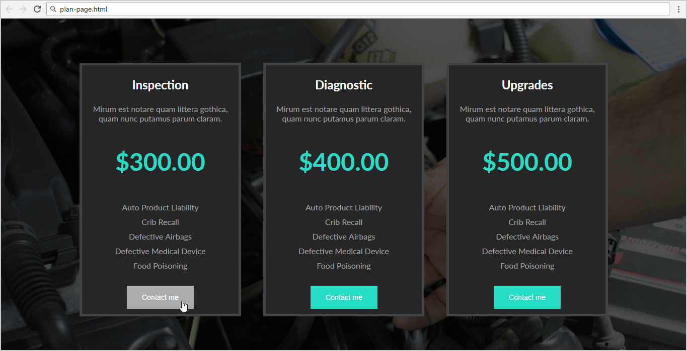
- Use the following HTML file: "plan-page.html".
  - You are NOT allowed to change the HTML code.
- Write the missing CSS file: "plan-page.css".

Constrains
- Body
  - Font Family: Lato, sans-serif;
  - Background: url(plan-page.jpg);
  - Text size: 16px
  - Width: 1180px;
- Section
  - Center the container
- Article
  - Background: #262626;
  - Display: inline-block;
  - Margin: 80px 20px 0 20px;
  - Border: 5px solid #424242;
  - Color: #a1a1a1;
- Article <h1>
  - Text size: 1.5em;
  - Color: #FFF;
- <p> with class="price"
  - Text size: 3em;
  - Text weight: bold;
  - Color: #27dcc4;
- <ul>
  - Padding: 0;
- <button>
  - Background: #27dcc4;
  - Color: #FFF;
  - Padding: 15px 30px;
  - Margin: 10px 0;
  - Text size: 0.9em;
  - Cursor: pointer;
  - Border: none;
- <button> on hover
  - Background: #ACACAC;
- <li>
  - List-style-type: none;
  - Padding: 5px 0;

